GENERATION AND ANALYSIS OF FREQUENCY MODULATED
(FM) AND OF PHASE MODULATED (PM) SIGNALS USING MATLAB

OBJECTIVES:
To generate and analyze Frequency Modulated (FM) and Phase Modulated (PM) signals using
MATLAB by varying the instantaneous frequency and phase of a carrier signal in accordance
with the message signal.

PROGRAM (MATLAB CODE):
clc;
clear;
close all;
Am=1;
Ac=1;
fm=5;
fc=50;
beta=5;
kp=5;
fs=1000;
t=0:1/fs:1;
m = Am*cos(2*pi*fm*t); % Message signal
c = Ac*cos(2*pi*fc*t); % Carrier signal
fm_sig = Ac*cos(2*pi*fc*t + beta*sin(2*pi*fm*t)); % FM
pm_sig = Ac*cos(2*pi*fc*t + kp*m); % PM
Df = beta*fm; % Frequency deviation
fprintf('Frequency Deviation = %d Hz\n',Df);
fprintf('FM Modulation Index = %d\n',beta);
subplot(4,1,1), plot(t,m), title('Message Signal')
subplot(4,1,2), plot(t,c), title('Carrier Signal')
subplot(4,1,3), plot(t,fm_sig), title('FM Signal')
subplot(4,1,4), plot(t,pm_sig), title('PM Signal')

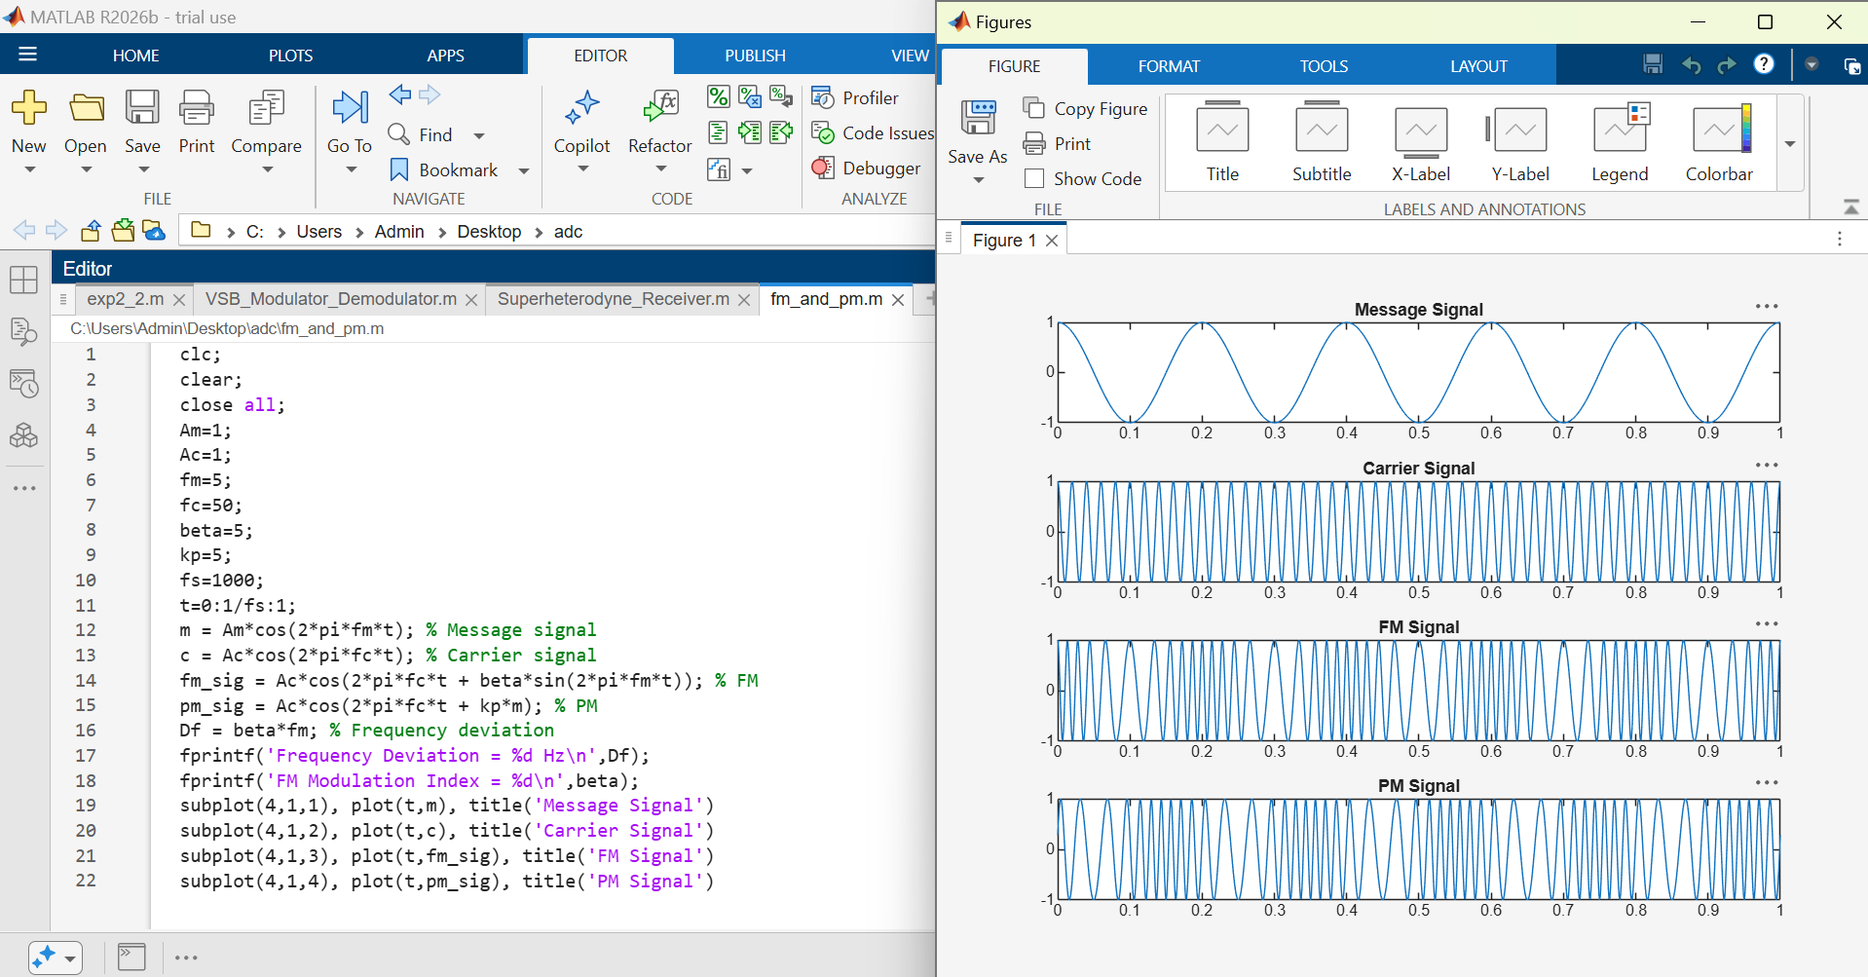
OUTPUT GRAPH:

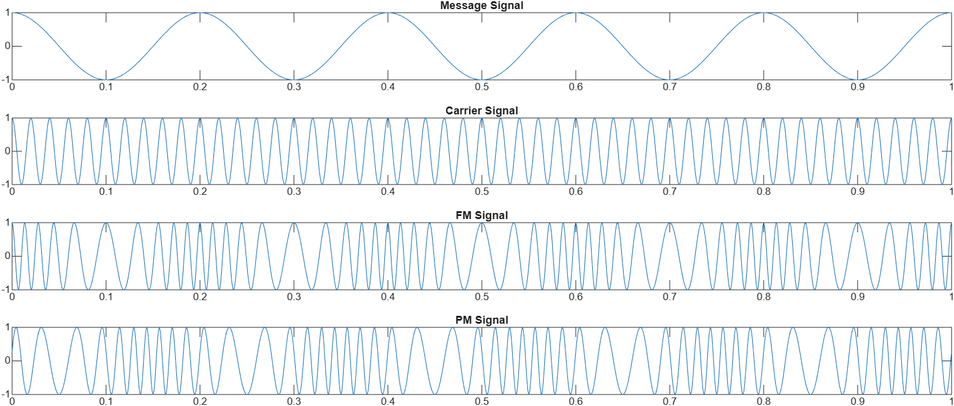

RESULT:
The Frequency Modulated (FM) and Phase Modulated (PM) signals were successfully generated using MATLAB by varying the instantaneous frequency and phase of the carrier signal according to the message signal.
• Frequency Deviation (Δf) = 25 Hz
• FM Modulation Index (β) = 5

